|  |  |  |  |
| --- | --- | --- | --- |
| 2 | | 23,599 | |
| **NUMERO DE FRONTERAS** | | **ENERGIA AGREGADA** | |
|  | | | |
| 6,303,466 | 13 | | 238,525 |
| INGRESO 2019 | DÍAS CERTIFICADOS 2019 | | ENERGIA RESPALDADA 2019 |
|  | | | |
| 86,637,866 | 209 | | 3,061,637 |
| INGRESO 2020 | DÍAS CERTIFICADOS 2020 | | ENERGIA RESPALDADA 2020 |
|  | | | |
| 45,388,962 | 124 | | 2,001,025 |
| INGRESO 2021 | DÍAS CERTIFICADOS 2021 | | ENERGIA RESPALDADA 2021 |

**HISTORICO REINTEGRO DDV**

|  |  |  |  |
| --- | --- | --- | --- |
|  | **2019** | **2020** | **2021** |
| **ENE** | - | 17.8 | 0.11 |
| **FEB** | - | 17.42 | - |
| **MAR** | - | 23.62 | - |
| **ABR** | - | - | - |
| **MAY** | - | 5.36 | 10.83 |
| **JUN** | - | 12.03 | 5.46 |
| **JUL** | - | 6.14 | 8.79 |
| **AGO** | - | 1.93 | 12.47 |
| **SEP** | - | 1.14 | 4.25 |
| **OCT** | - | 0.99 | 3.48 |
| **NOV** | - | - | - |
| **DIC** | 6.3 | 0.19 | - |

**Los valores de la tabla están en millones de COP**

**REINTEGRO MECANISMO DDV OCTUBRE 2021**

|  |  |  |  |  |  |
| --- | --- | --- | --- | --- | --- |
| FECHA | TIPO DIA | CANTIDADES RESPALDO | PRECIO PONDERADO USD | TRM | PNETO |
| 2021-10-18 | Domingo - Festivo | 8,399 | 5.98 | 3,784.44 | 170,309 |
| 2021-10-19 | Martes | 8,687 | 5.98 | 3,784.44 | 176,149 |
| 2021-10-20 | Miércoles | 8,735 | 5.98 | 3,784.44 | 177,122 |
| 2021-10-21 | Jueves | 8,471 | 5.98 | 3,784.44 | 171,769 |
| 2021-10-22 | Viernes | 8,735 | 5.98 | 3,784.44 | 177,122 |
| 2021-10-23 | Sábado | 8,735 | 5.98 | 3,784.44 | 177,122 |
| 2021-10-25 | Lunes | 8,663 | 5.98 | 3,784.44 | 175,663 |
| 2021-10-26 | Martes | 8,399 | 5.98 | 3,784.44 | 170,309 |
| 2021-10-27 | Miércoles | 8,687 | 5.98 | 3,784.44 | 176,149 |
| 2021-10-28 | Jueves | 23,614 | 5.98 | 3,784.44 | 478,828 |
| 2021-10-29 | Viernes | 23,614 | 5.98 | 3,784.44 | 478,828 |
| 2021-10-30 | Sábado | 23,614 | 5.98 | 3,784.44 | 478,828 |
| 2021-10-31 | Domingo - Festivo | 23,326 | 5.98 | 3,784.44 | 472,989 |

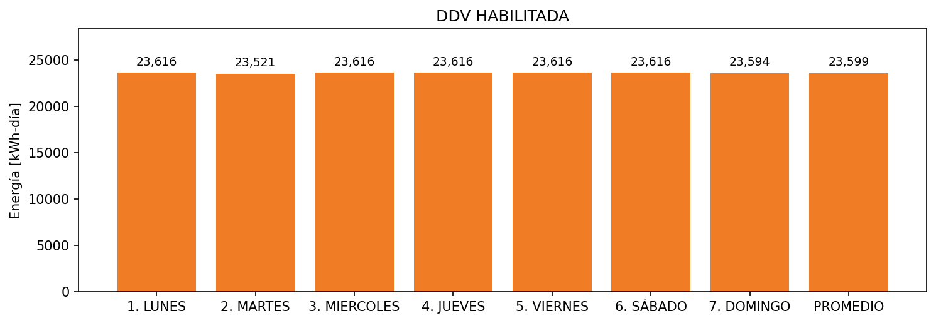

|  |  |  |  |  |  |  |  |  |  |
| --- | --- | --- | --- | --- | --- | --- | --- | --- | --- |
| **FRONTERA** | **COD SIC** | **FRT DDV** | **TIPO DDV** | **PROMEDIO** | **PRÓXIMA ACTUALIZACIÓN** | **MARGEN DE ERROR** | **ÚLTIMA PRUEBA DDV** | **DÍAS PARTICIPACIÓN** | **FECHA REFERENCIA PRÓXIMA PRUEBA DDV** |
| CENTRO COMERCIAL BUENAVISTA AREA COMUN | Frt08130 | Frt35787 | LBC | 14,863 | 2022-01-20 | 3,14 | 2021-10-20 | 4.0 | 2022-03-08 |
| CENTRO COMERCIAL BUENAVISTA | Frt03830 | Frt35146 | LBC | 8,736 | 2022-03-02 | 2,66 | 2021-10-07 | 13.0 | 2022-02-27 |